**FPT ACADEMY INTERNATIONAL**

**FPT – APTECH COMPUTER EDUCATION**



**Centre Name: ACE-HCMC-2-FPT.**

**Address: 590 Cach Mang Thang 8, District 3, Ho Chi Minh City, Viet Nam.**

**GIFTS ONLINE**

|  |  |  |
| --- | --- | --- |
| **Supervisor** | PHAM THI LANH | |
| **Semester** | 1 | |
| **Batch No** | T1.2008.M0 | |
| **Group No** | 8 | |
| **Order** | **Full name** | **Roll No.** |
| 1. | NGUYEN SON NGOC | Student1273498 |
| 2. | NGUYEN ANH TAI | Student1270670 |
| 3. | NGUYEN TRUONG THINH | Student1273004 |
| 4. | NGUYEN XUAN DUC | Student1273002 |



Month 10 Year 2020



This is to certify that

Mr: Nguyen Son Ngoc

Mr: Nguyen Anh Tai

Mr: Nguyen Truong Thinh

Mr: Nguyen Xuan Duc

Has successfully Designed & Developed

**GIFTS ONLINE**

Submitted by:

Pham Thi Lanh

Date of issue:

October, 23rd 2020

Authorized Signature:

Contents

Objectives of the project 4

Problem Statement 5

REVIEW 1 6

REQUIREMENT SPECIFICATION 7

CUSTOMERS REQUIREMENT SPECIFICATIONS (CRS) 8

ARCHITECTURE & DESIGN OF THE SYSTEM 9

SITEMAP 10

WEBSITE LAYOUTS 11

**1. Homepage:** 11

**2. Informative pages:** 13

TASK SHEET 1 14

WEB INTERFACE 15

1. Homepage 15

2. Shop Page 20

3. Shop Location 23

4. About Us 23

5. Login & Sign up 24

6. Search items 25

7. Sale, New Items, Best Sellers 26

8. FAQ & HELP, Feedback 27

9. Favorite and Cart 28

10. Categories Page 29

11. Item Details Page 33

12. Footer 34

13. Payment Page 35

TIME MANAGEMENT 36

TASK SHEET 2 37

CHECKLIST VALIDATION 39

REFERRENCE 41

# Objectives of the project

The Objective of this program is to give a sample project to work on real life projects. These applications help you build a larger more robust application.

The objective is not to teach you JavaScript/Dreamweaver but to provide you with a real life scenario and help you create basic applications using the tools.

You can revise the chapters before you start with the project.

This project is meant for students who have completed the module of ***HTML5***. These programs should be done in the Lab sessions with assistance of the faculty if required.

It is very essential that a student has a clear understanding of the subject. Students should go through the project and solve the assignments as per requirements given.

Kindly get back to eProjects Team in case of any doubts regarding the application or its objectives.

# Problem Statement

GIFTS ONLINE is selling various types of Gift Items. The company advertises by distributing the pamphlets, advertising on television and so on. Due to rapid development in internet field, the company decides to launch a website where people will get all the information about the various products available with them easily.

You are supposed to create a website for them with the below mentioned requirement specifications.

The website is to be developed for the Windows Platform using HTML5, JavaScript and Geolocation. The site should work well in all leading browsers including Chrome, IE, Firefox etc.

# REVIEW 1

# REQUIREMENT SPECIFICATION

**The Web site is to be created based on the following requirements.**

1. The Home Page should be created making use of Frames with a suitable logo.
2. Home Page should contain details of Gift Items with suitable images.
3. The site should display a menu which will contain the options for brief introduction about the various gift items available, location of the shop and any other information if required.
4. The information about products should be presented in two ways:
   * + - 1. Information should be available category wise, wherein user can click on a particular category and should be able to view all the products related to the category available with complete information. Eg. Category can be “Mugs”, “Cards”, Bracelets” etc. with suitable sub-categories been defined.
         2. Information should be categorized according to the brand names of the products like if a User wants to see only “Hallmark” products or any other company’s products then he/she can click on a Link/button/menu etc and can see only that Brand products.
5. When a user selects any particular brand, a list of products for that brand will be displayed
6. A brief summary of features of individual products should be displayed on the Web Page along with the product but detailed Features should be stored in Individual Word documents which can be downloaded or viewed by the User who wishes to see the same.
7. The user should also be able to compare the various products of different as well as similar brands.
8. There should be a “Contact Us” page which will have the Address of the Company which is as follows and the mail address which when clicked will invoke the local mail client from where they can send an email. Address of the Company should be displayed using GeoLocation API (eg. GoogleMaps).

# CUSTOMERS REQUIREMENT SPECIFICATIONS (CRS)

**1.Client: GIFTS ONLINE**

**2.Business/Project Objectives:**

Provide a website to displays the programs and services about gift shop such as: “Favorites”, “Sale”, “Best Seller”, “Cart”, “About Us”, “Feedback”…

Enable customers to see what event that they would like. Easier interactive with us.

**3.Hardware Requirement:**

* A minimum computer system that will help you access all the tools in the courses is a Pentium 166 or better
* 64 Megabytes of RAM or better

**4.Software Requirements:**

* Notepad/HTML editor
* Dreamweaver
* IE 5.0/ Netscape 6.0

# ARCHITECTURE & DESIGN OF THE SYSTEM

**CLIENT**

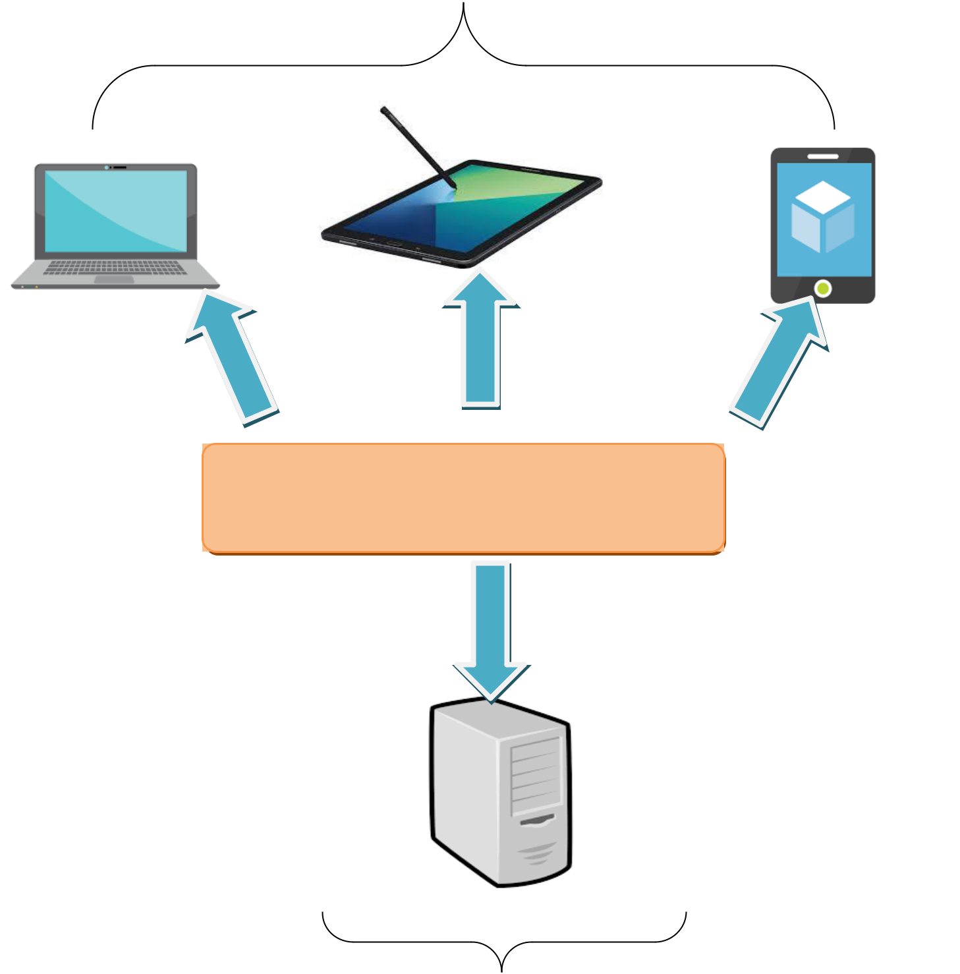

Font End technologies

(HTML5, CSS3, Bootstrap, jQuery)

**SERVER**

# SITEMAP

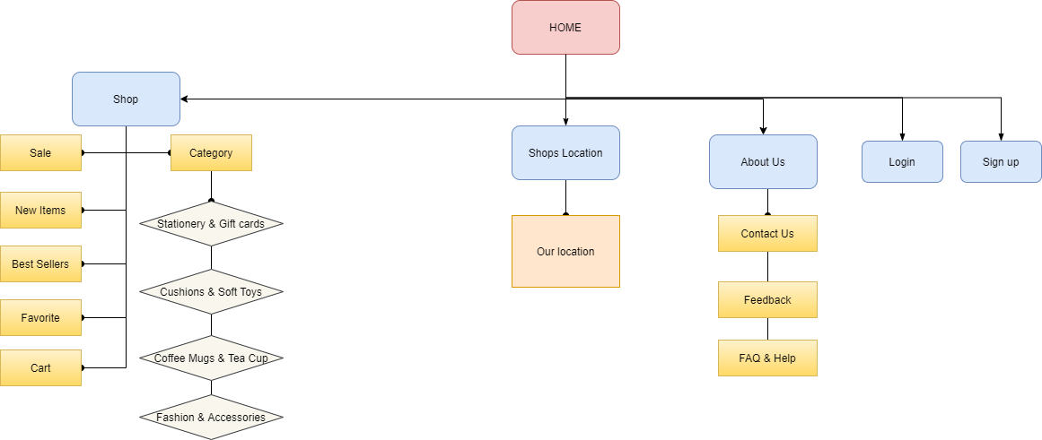

# WEBSITE LAYOUTS

**Here are our layouts which will show you how we brainstormed ideas for the Gift shop’s web pages. Because of being Gift shop website, we tried to build them DYNAMIC, COMFY and INFORMATIVE as much as possible.**

**The website is going to have several pages which include different information and products in the same main layout.**

## **1. Homepage:**

This layout below describes how we created our Homepage which contain three important parts:

* *Page-header and Navigation bar:*

Page-header must have gift shop’s logo and other links like contact us, shop, login, sign up. Search gifts bar is optional.

Navigation bar is one of the most crucial sections in the whole website which will indicate people how they interact with us. It provide some information like Shop, Shops location, About Us, Login, Sign up, Favorite, Cart, etc... Each section must have brief information.

* *Content:*

This section is customized according to the title of each website, the Home page will display some typical products of Gifts Online and optional features of each product.

* *Footer:*

The last part of all our websites is undoubtedly Footer which will reveal some convenient ways to contact your shop on various social channels like Phone, Email, Facebook, Twitter as well as display the address and location of our shop.

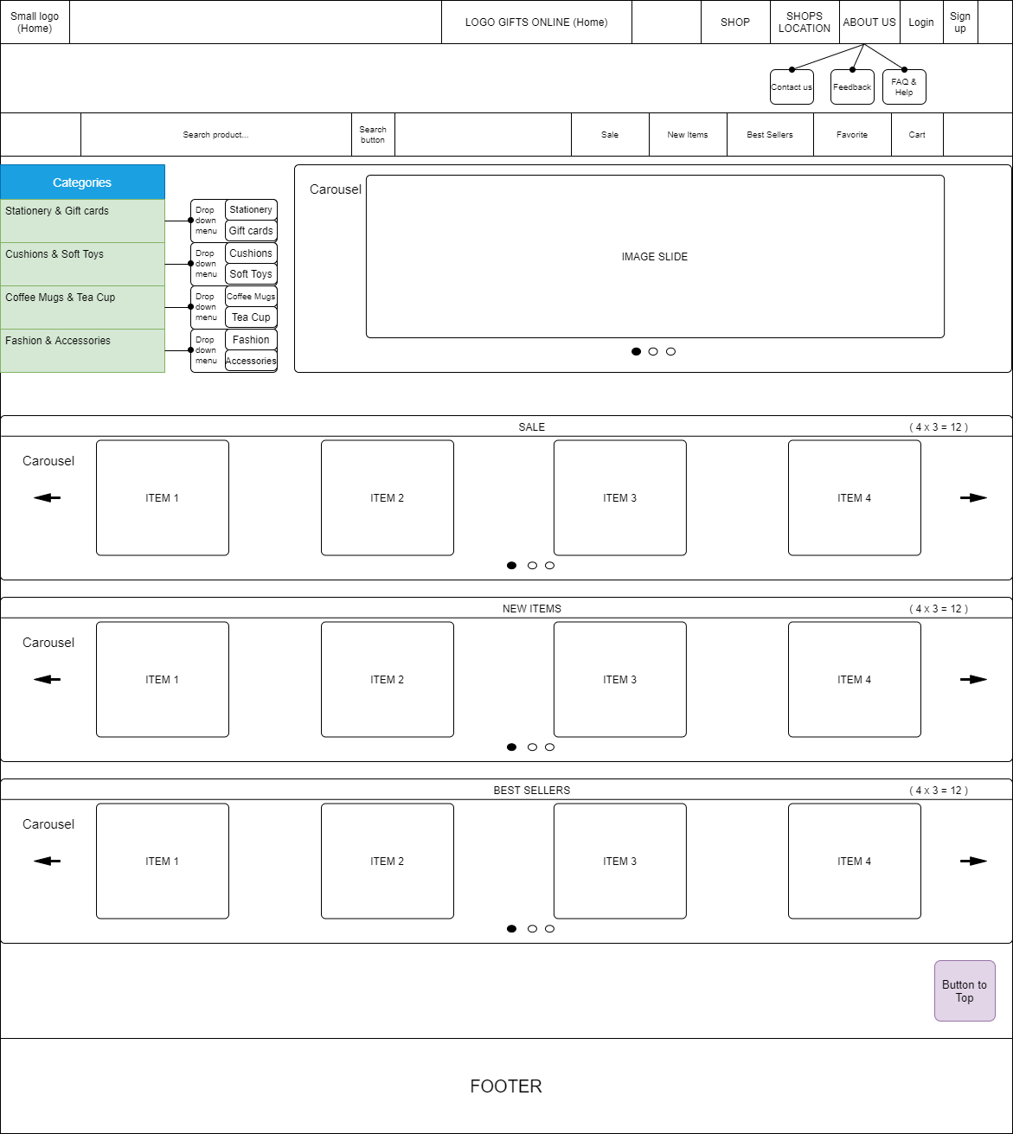

## **2. Informative pages:**

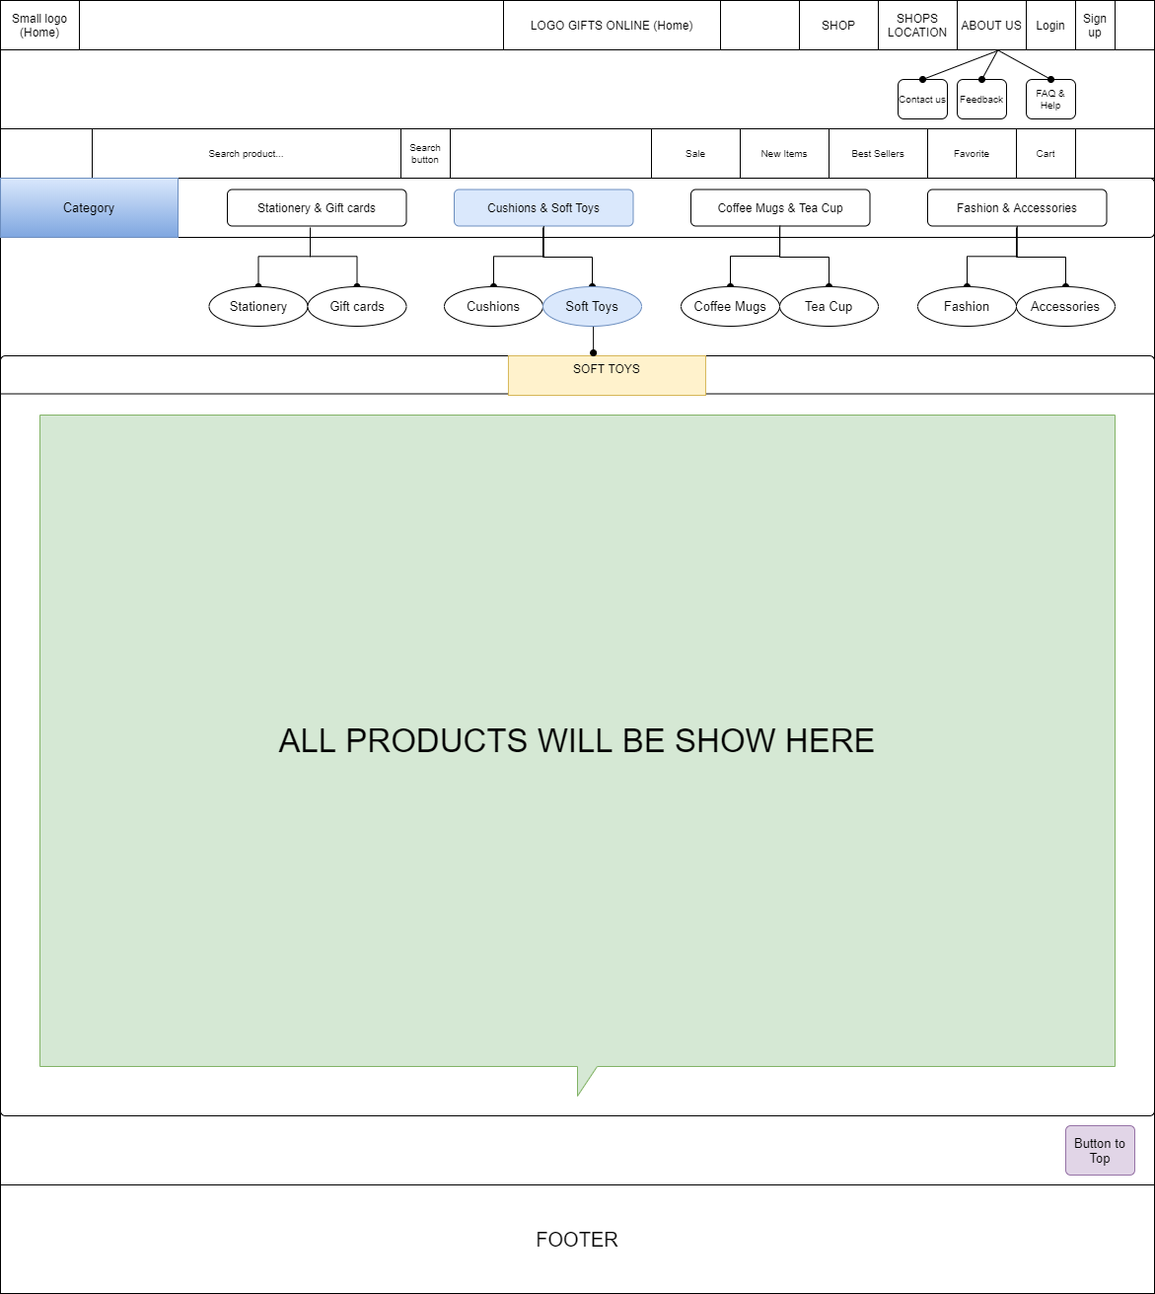This layout we will apply for most of other pages (About Us, Feedback, FAQ & Help...) which provide people different information about the Cambridge hospital. It also has the same Page-header, Navigation bar and Footer as Homepage, but the main content is changed. Interestingly, we will change design “Category” bar with class “active” to help people enter another related website easier.

# TASK SHEET 1

|  |  |  |  |  |  |  |
| --- | --- | --- | --- | --- | --- | --- |
| **Project Ref. No.** | **Project Title** | **Activity Plan Prepared by** | **Date of Preparation of Activity Plan** | | | |
| **Task** | **Actual Start Date** | **Actual Days** | **Teammate Names** | **Status** |
| **Create layouts for website base on group discussion ideas** | GIFT ONLINE | Ngoc | 15/10/2020 | 2 | Ngoc  Tai  Thinh | Completed |
| **Draw layouts using Paint** | GIFT ONLINE | Ngoc | 17/10/2020 | 3 | Ngoc  Tai | Completed |
| **Write project report 1** | GIFT ONLINE | Ngoc | 16/10/2020 | 3 | Ngoc | Completed |
| **Homepage design and coding (include navigation bar and footer)** | GIFT ONLINE | Ngoc  Tai | 18/10/2020 | 4 | Ngoc  Tai  Thinh | Completed |

|  |  |
| --- | --- |
| Signature of Faculty | Signature of Leader Team |
|  |  |
|  |  |

# WEB INTERFACE

## Homepage

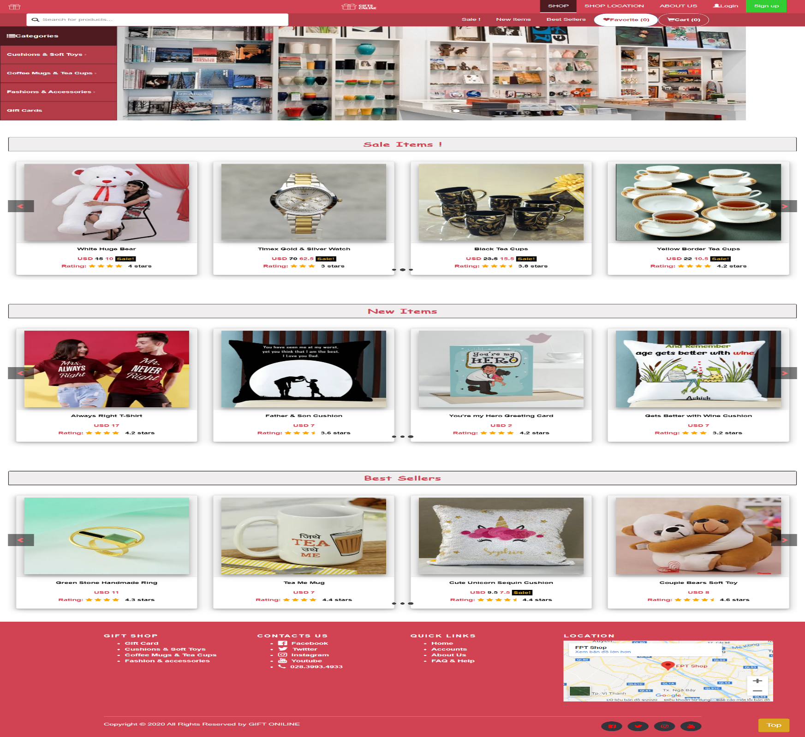This is our Homepage about GIFTS ONLINE. We used slide in Bootstrap to show item's theme in shop follow three headers: Sale Items! ; New Items and Best Sellers.

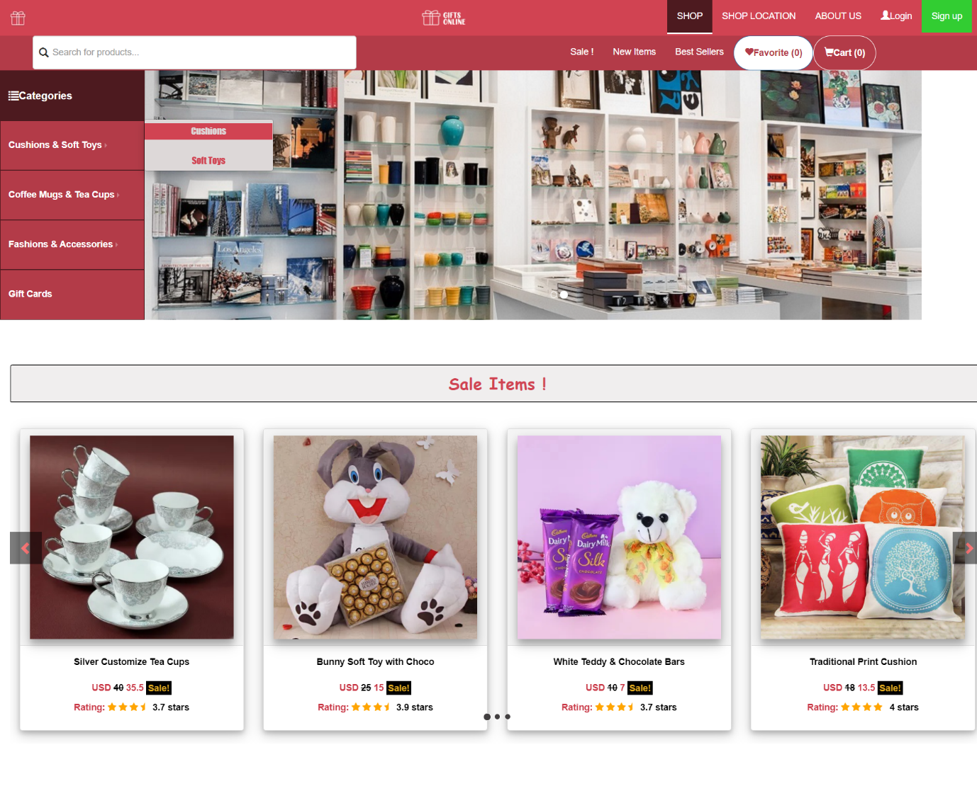When visitors hover the navigation bar at Categories, a menu bar will appear with its links as 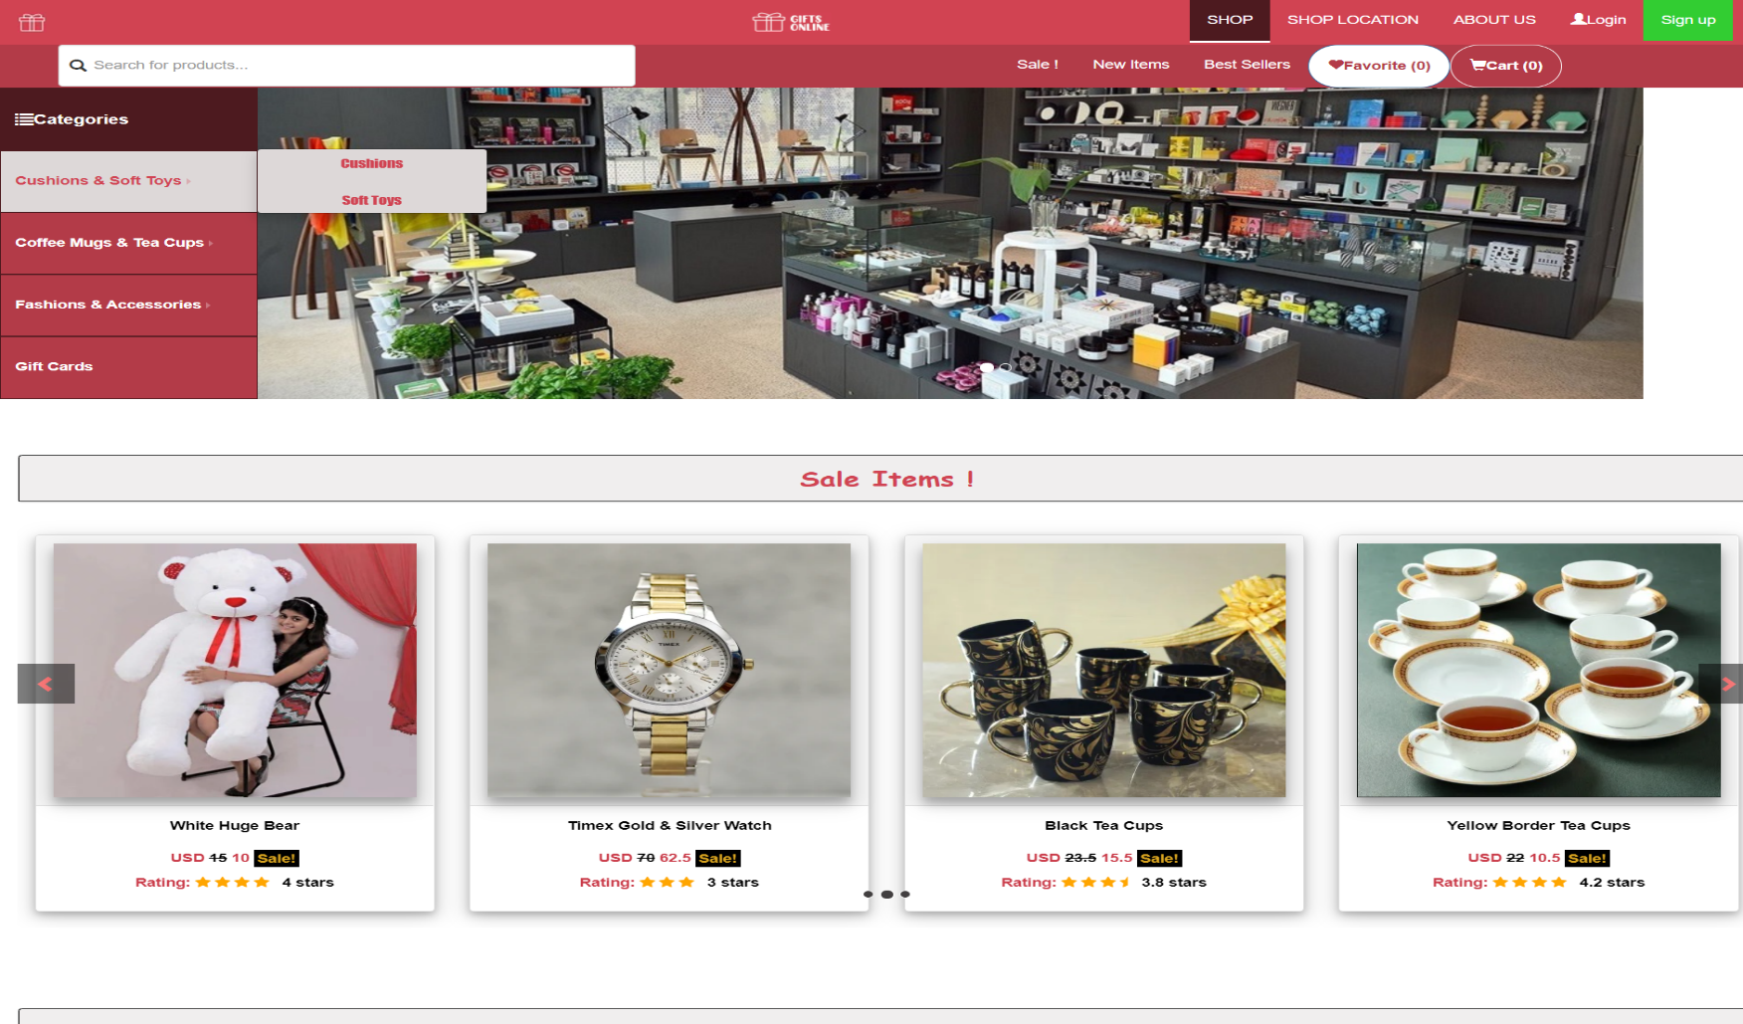you see above picture.

|  |  |
| --- | --- |
| **TITLE** | **DESCRIPTION** |
| Home | - Carousels which show some highlights as Sale, New Items, Best Sellers  - Some quick methods to use our important services in shop's categories:  + Cushions, Soft Toys, Coffee Mugs, Tea Cups, Fashions, Accessories, Gift Cards.  - Some special news about events to update latest information about items people concerned.  - Footer with different ways to contact us and some related associations. |
| Shop | - Clicking on the Shop will link to the Products page which displays all of the shop's items.  - We have a total of three pages showing all the items currently in the shop. |
| Shop Location | - When click on the shop location, it will scroll down to the footer where there is a map showing the location of the shop in the lower right corner of the footer. |
| About Us | - Displays basic information about the shop as well as some contact information about the shop. |
| Login & Sign up | - Help customers log in or create a login account to manage their buying account easier and customers are also required to have it for purchases, payments and receiving goods. |
| Search | - A quick method to search for an item by name and link to its detailed information page. |
| Sale!, New Items, Best Sellers at Bar menu | - Sale, New items and Best Sellers will immediately auto scroll down to the title and items of each category corresponding to the title below when clicking on them while on home page. In addition, it will return to the home page when clicked while on other pages. |
| Favorite | - Show items added to the Favorite and manage it from here. |
| Cart | - Show items added to the Cart and manage it from here, support cart payments. |
| Categories:  +Cushions & Soft Toys  + Coffee Mugs & Tea Cups  + Fashions & Accessories  + Gift cards | - Dropdown Cushions, Soft Toys when hovering into Cushions & Soft Toy, customers can click on them to see the desired item or click directly on Cushions & Soft Toy to view the items of both categories above.  - As same as Cushions & Soft Toys.  - As same as Cushions & Soft Toys.  - As same as Cushions & Soft Toys. |
| Cushions & Soft Toys | - Display only items about Cushions and Soft Toy.  +Cushions: Display only items about Cushions.  + Soft Toys: Display only items about Soft Toys. |
| Coffee Mugs & Tea Cups | - Display only items about Coffee Mugs and Tea Cups.  +Coffee Mugs: Display only items about Coffee Mugs.  + Tea Cups: Display only items about Tea Cups. |
| Fashions & Accessories | - Display only items about Fashions and Accessories.  + Fashions: Display only items about Fashions.  + Accessories: Display only items about Accessories. |
| Gift cards | - Display only items about Gift cards. |
| Footer | - Includes contact us, phone number, Shop Location map, social media links and some other information linked to specific pages when clicked. |
| Scroll Top button | - Scroll back to the top of the page |
| Contact us | - Shop’s address with map, main contacts.  - Phone number to call us.  - Social networks as Twitter, Facebook, Youtube, Instagram to connect with us.  -FAQ & Help: Lists some common questions and problems, and suggests how to solve them. This also includes Feedback about our Shop. |
| Add to Favorite | - Add item to favorites list. |
| Add to Cart | - Add item to Cart. |
| Buy Now | - Pay for item. |
| Payment | - Pay method. |

## Shop Page

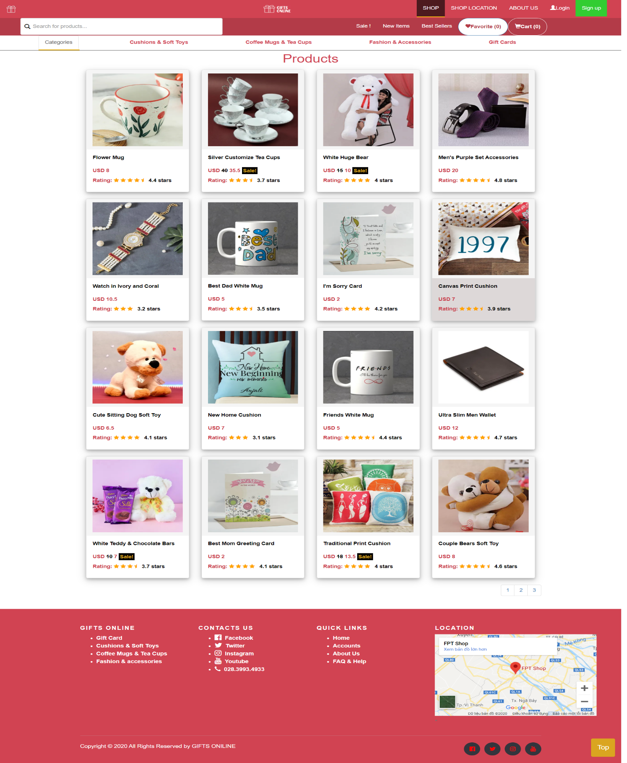Clicking on the Shop will link to the Products page which displays all of the shop's items. We have a total of three pages showing all the items currently in the shop:

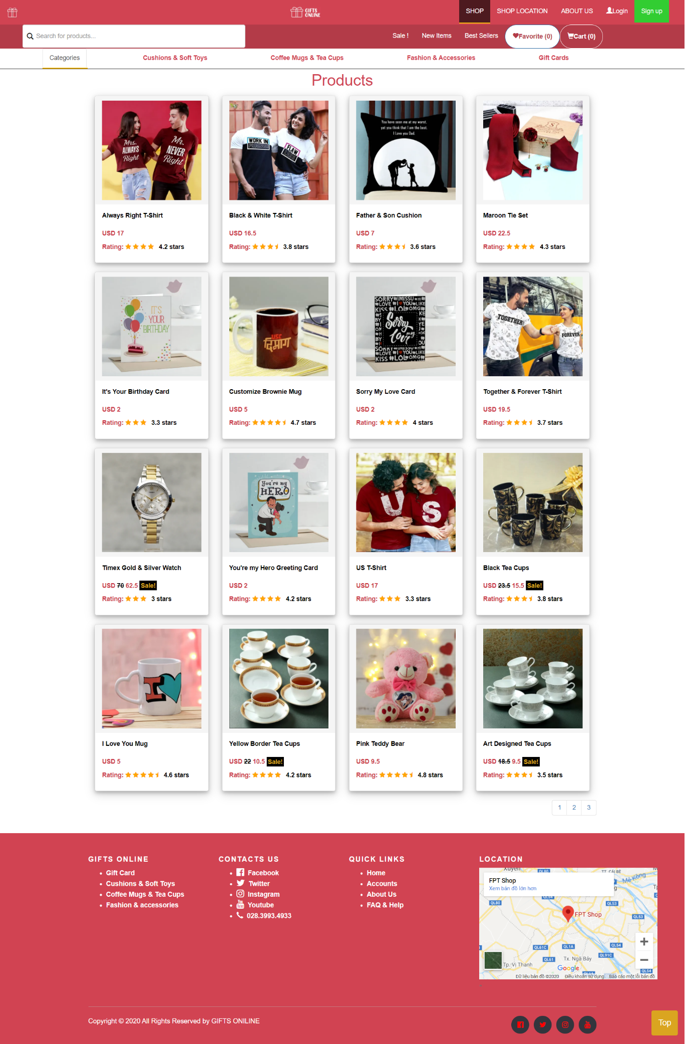

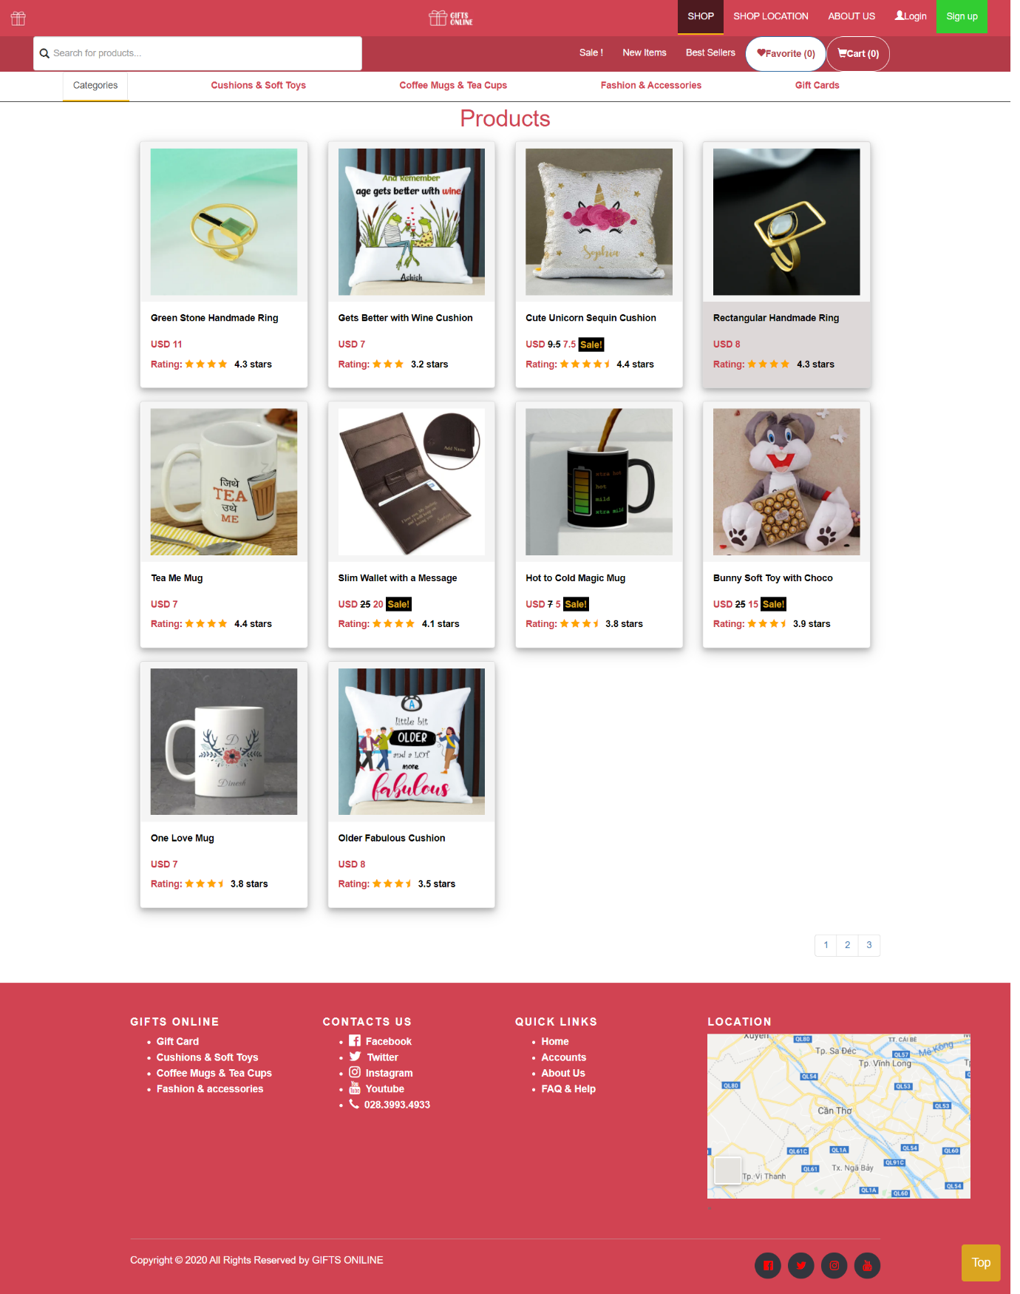

## Shop Location

When click on the shop location, it will scroll down to the footer where there is a map showing the location of the shop in the lower right corner of the footer.

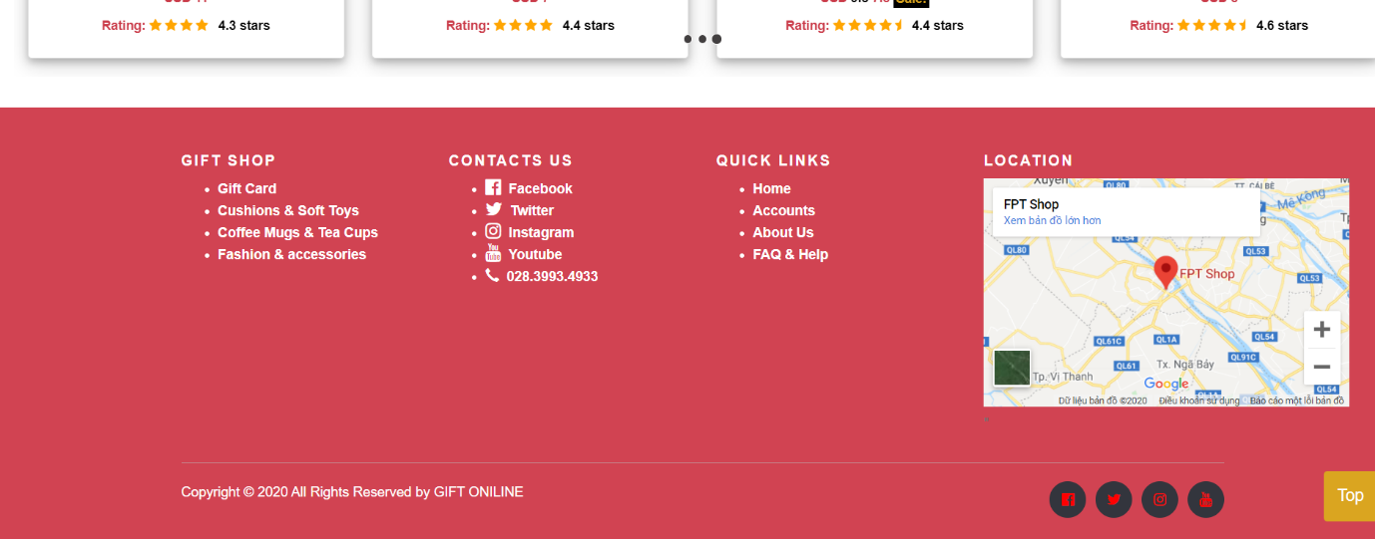

## About Us

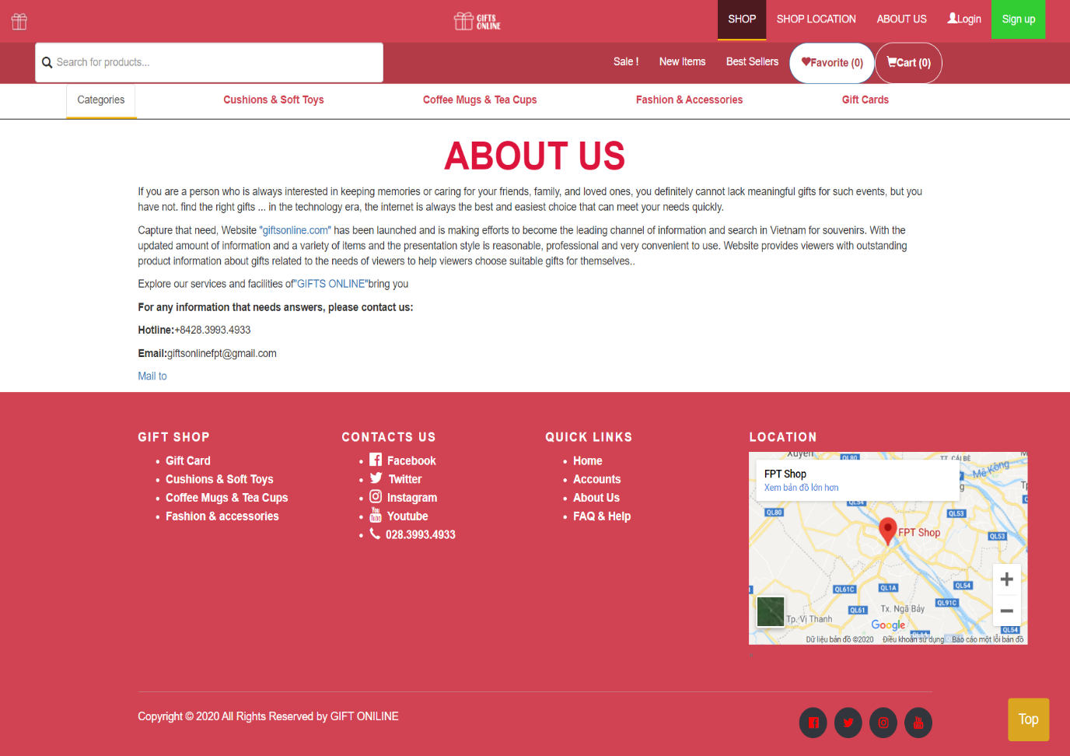Displays basic information about the shop as well as some contact information about the shop.

## Login & Sign up

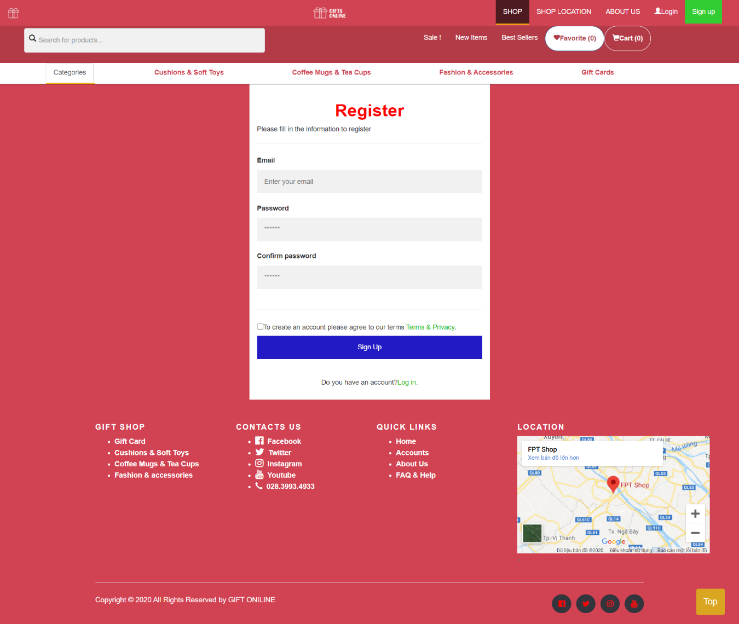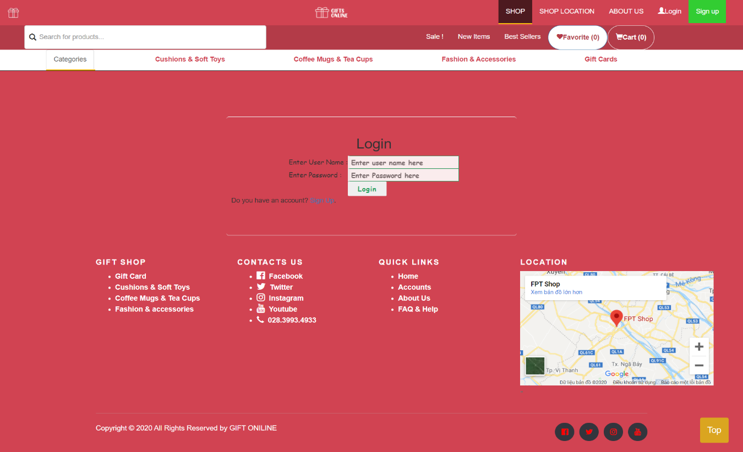Help customers log in or create a login account to manage their buying account easier and customers are also required to have it for purchases, payments and receiving goods.

## Search items

A quick method to search for an item by name and link to its detailed information page.

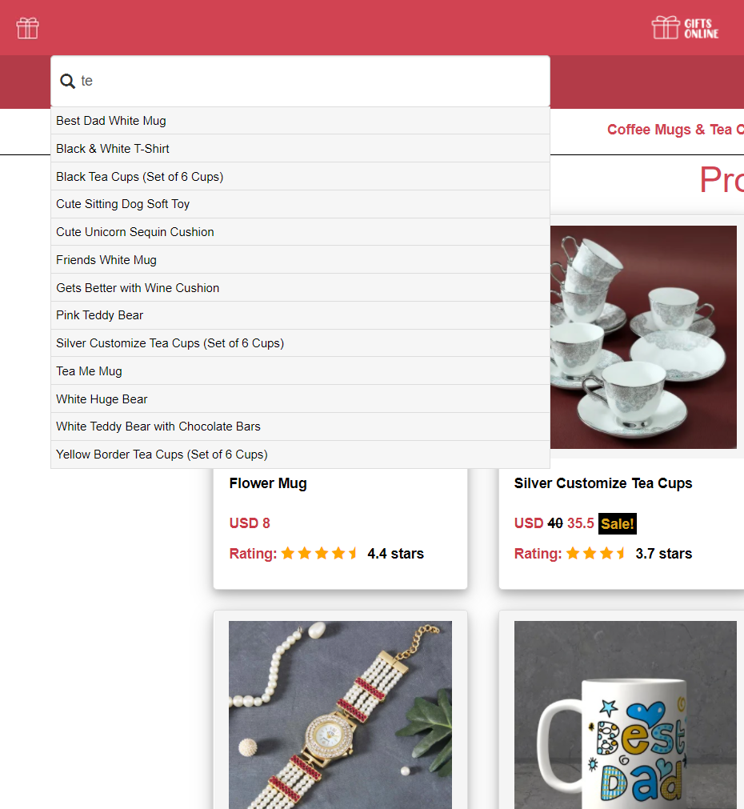

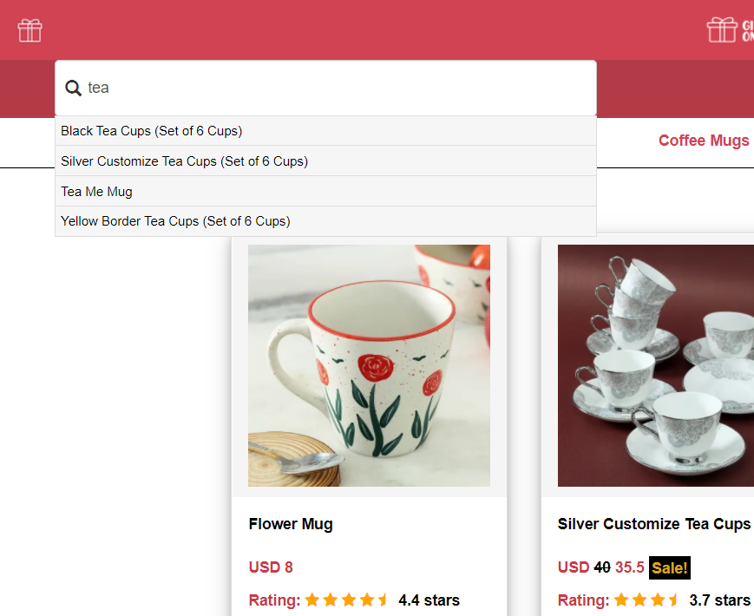

## Sale, New Items, Best Sellers

Will immediately auto scroll down to the title and items of each category corresponding to the title below when clicking on them while on home page.

In addition, it will return to the home page when clicked while on other pages.

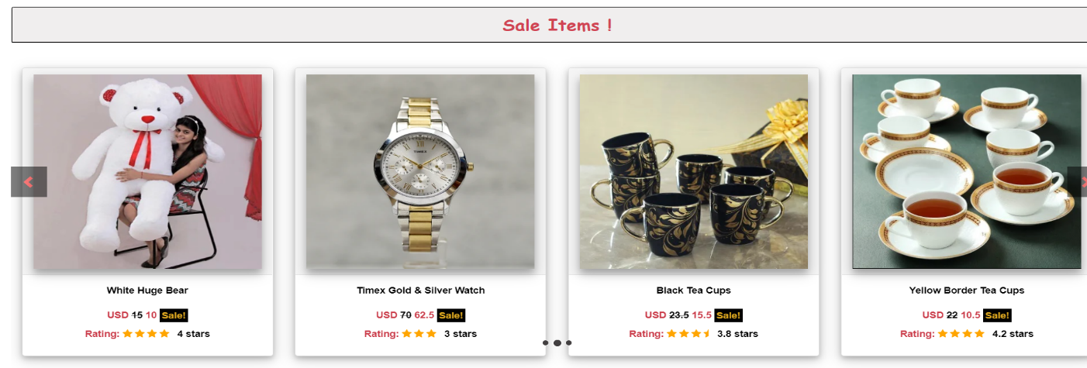When click on Sale at bar header

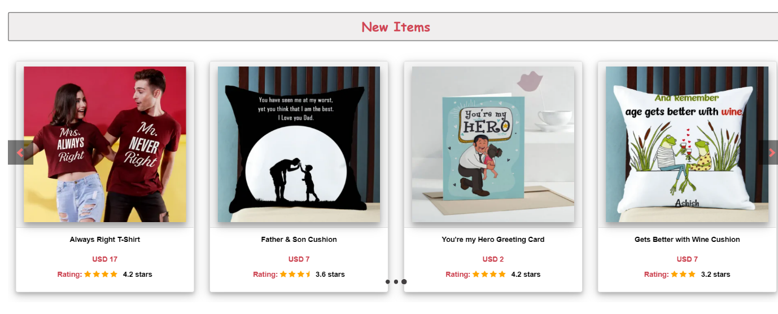When click on New Items at bar header

When click on Best Sellers at bar header

## 

## FAQ & HELP, Feedback

Lists some common questions and problems, and suggests how to solve them.

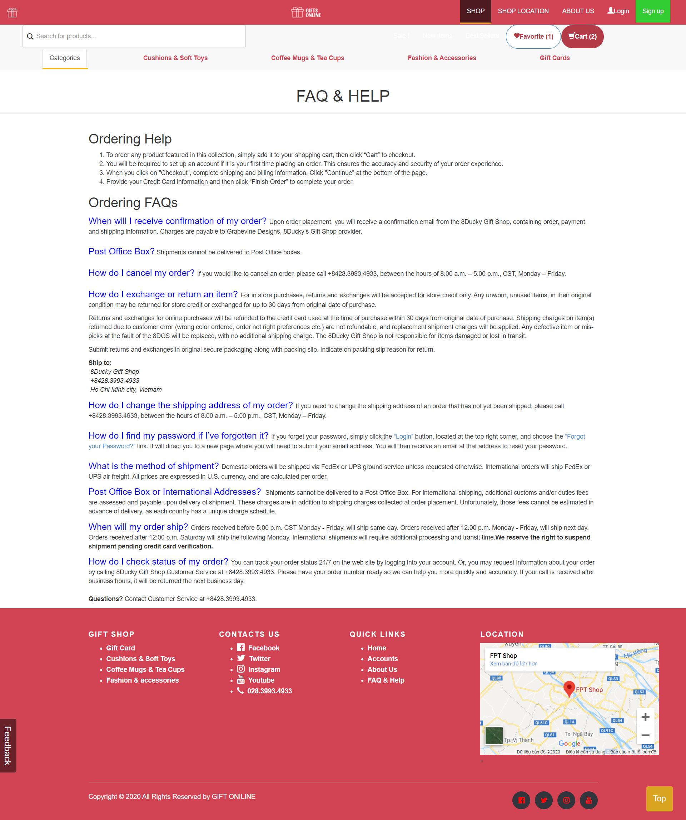This also includes Feedback about our Shop.

## Favorite and Cart

- Show items added to the Favorite and manage it from here.

- Show items added to the Cart and manage it from here, support cart payments.

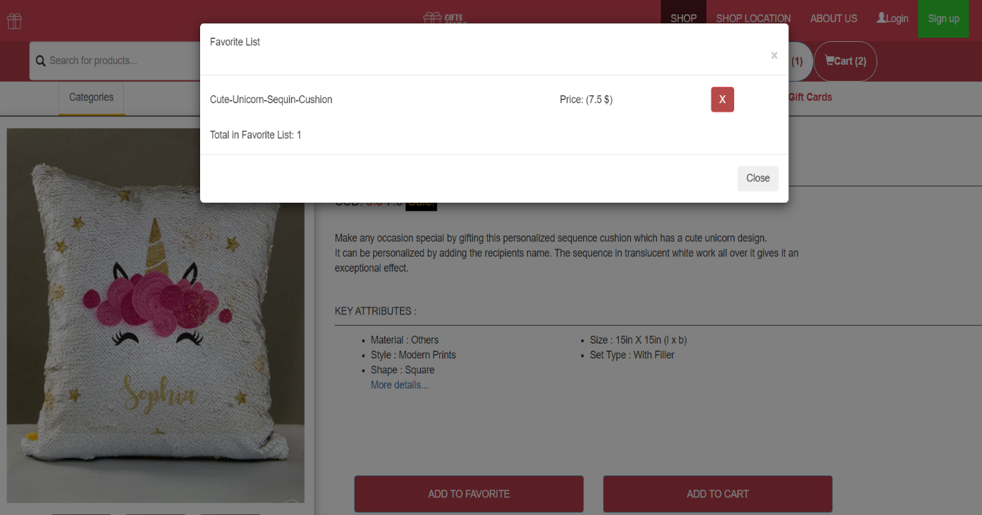FAVORITE

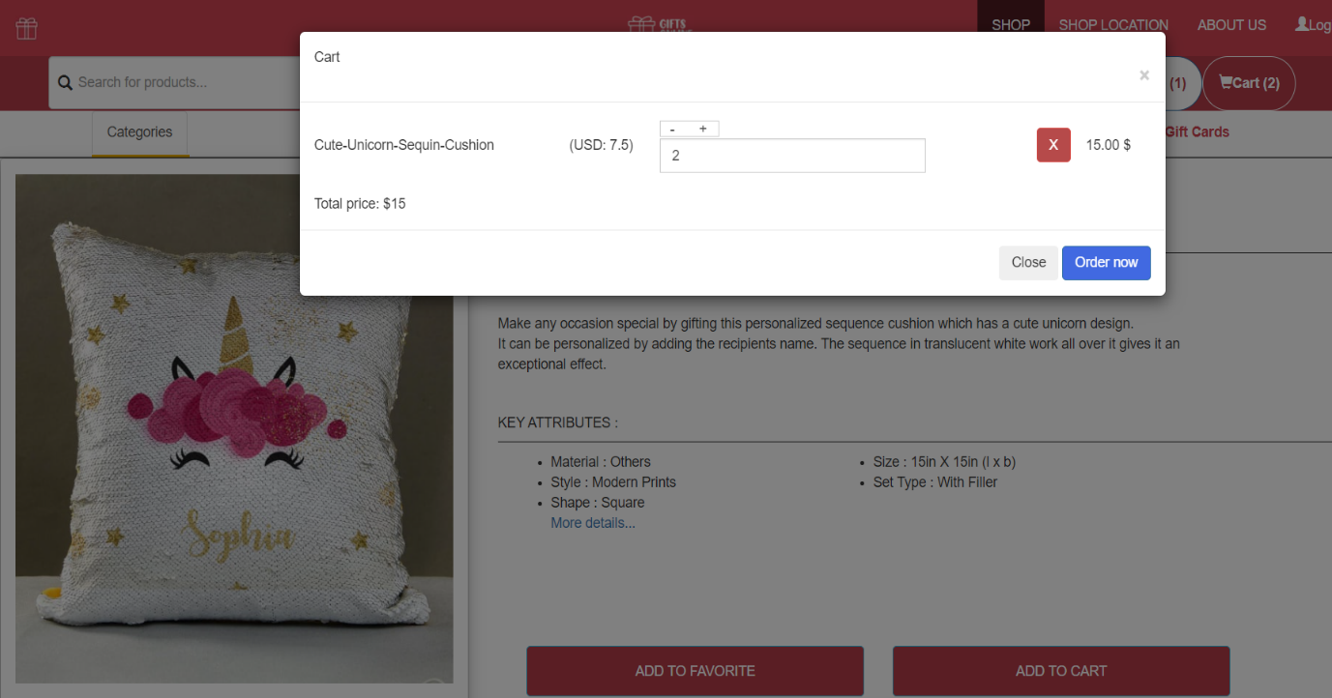CART

## Categories Page

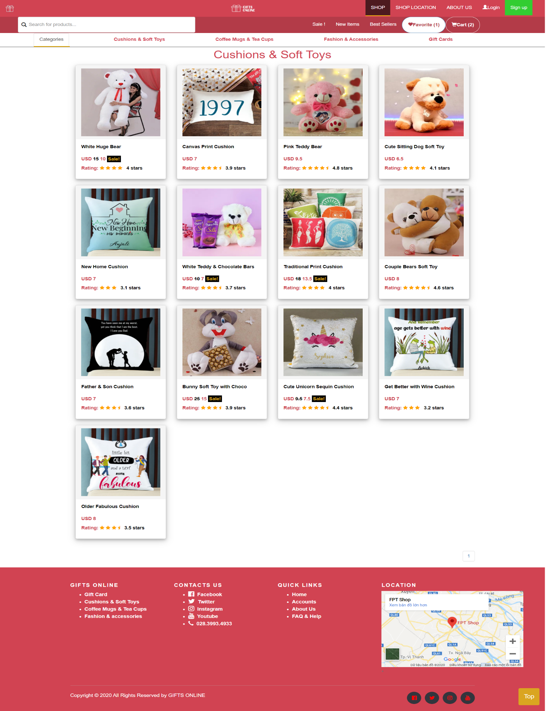Show only items according to the selected category.

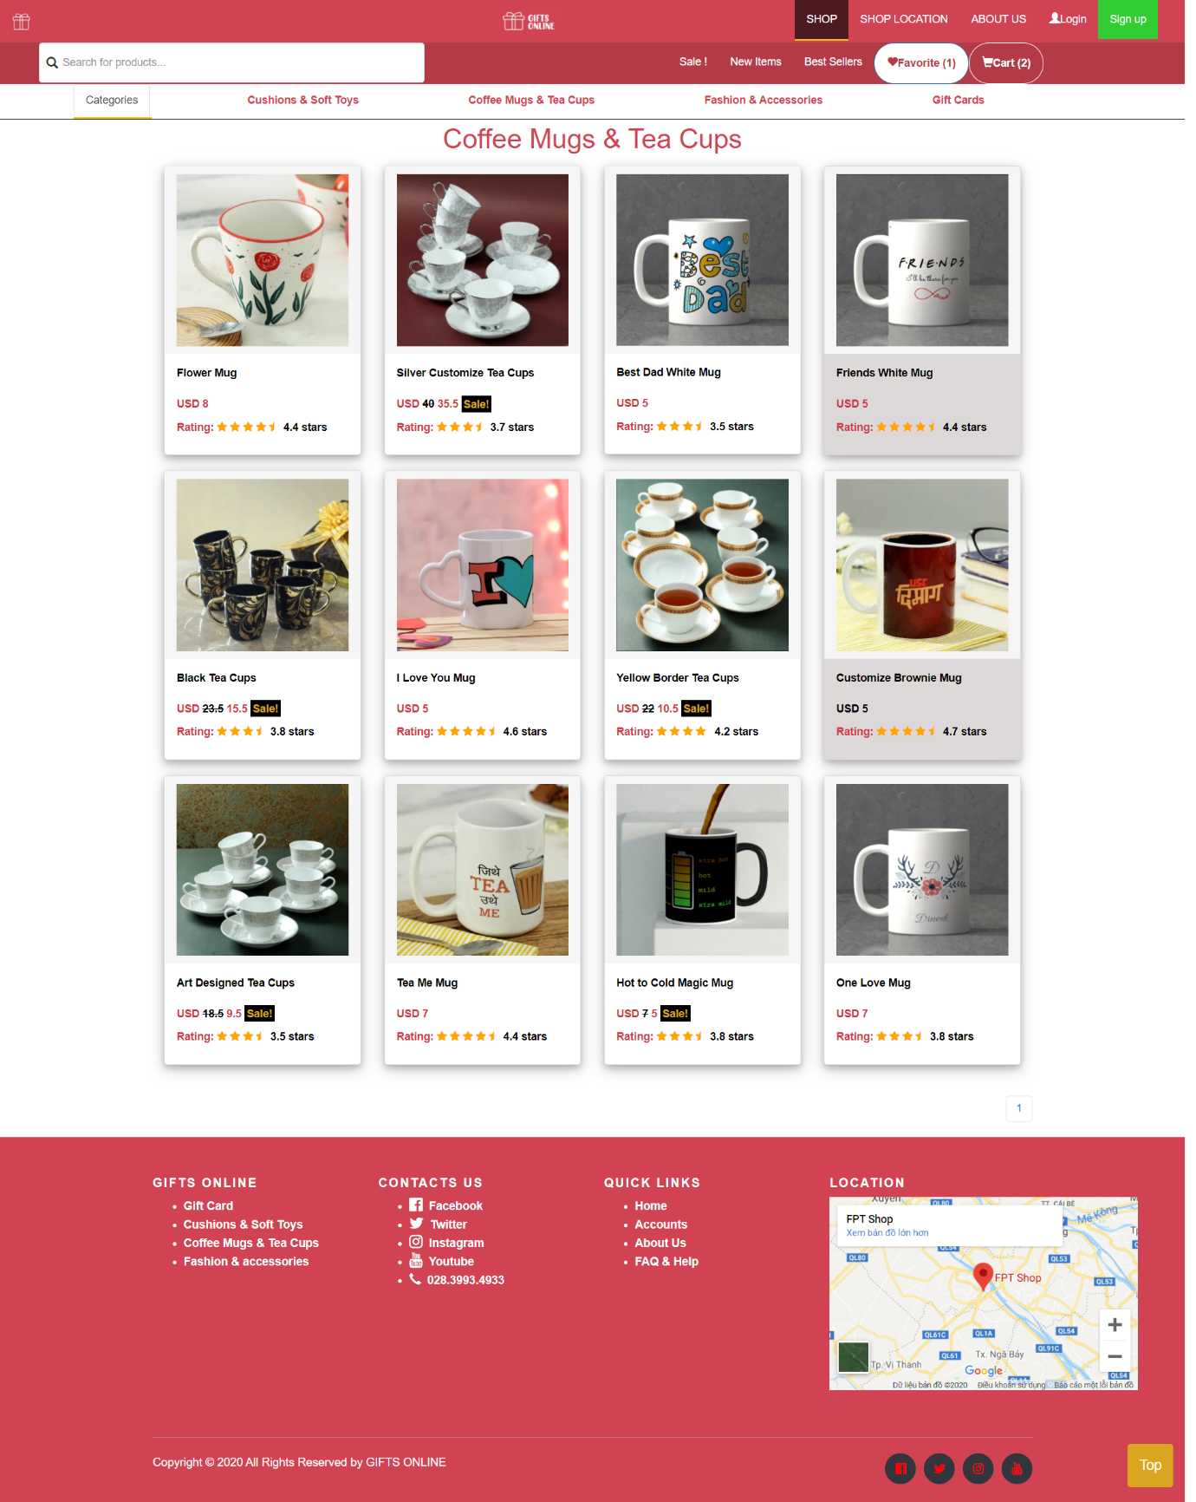

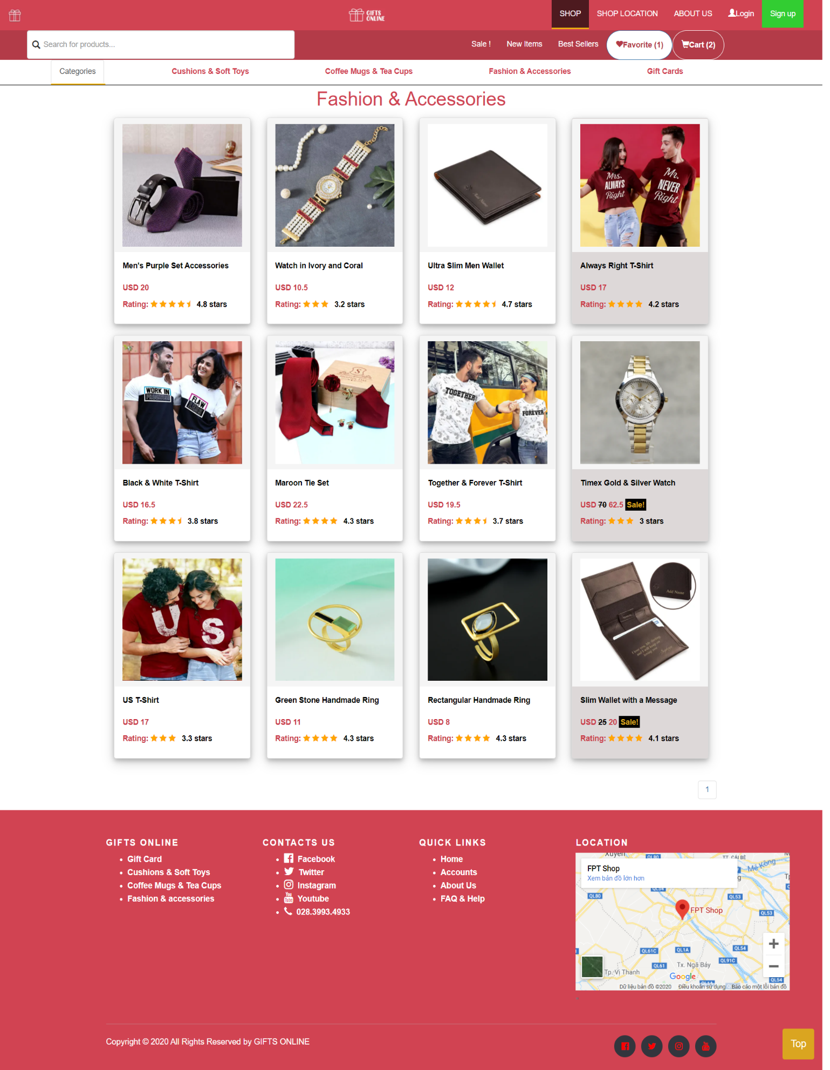

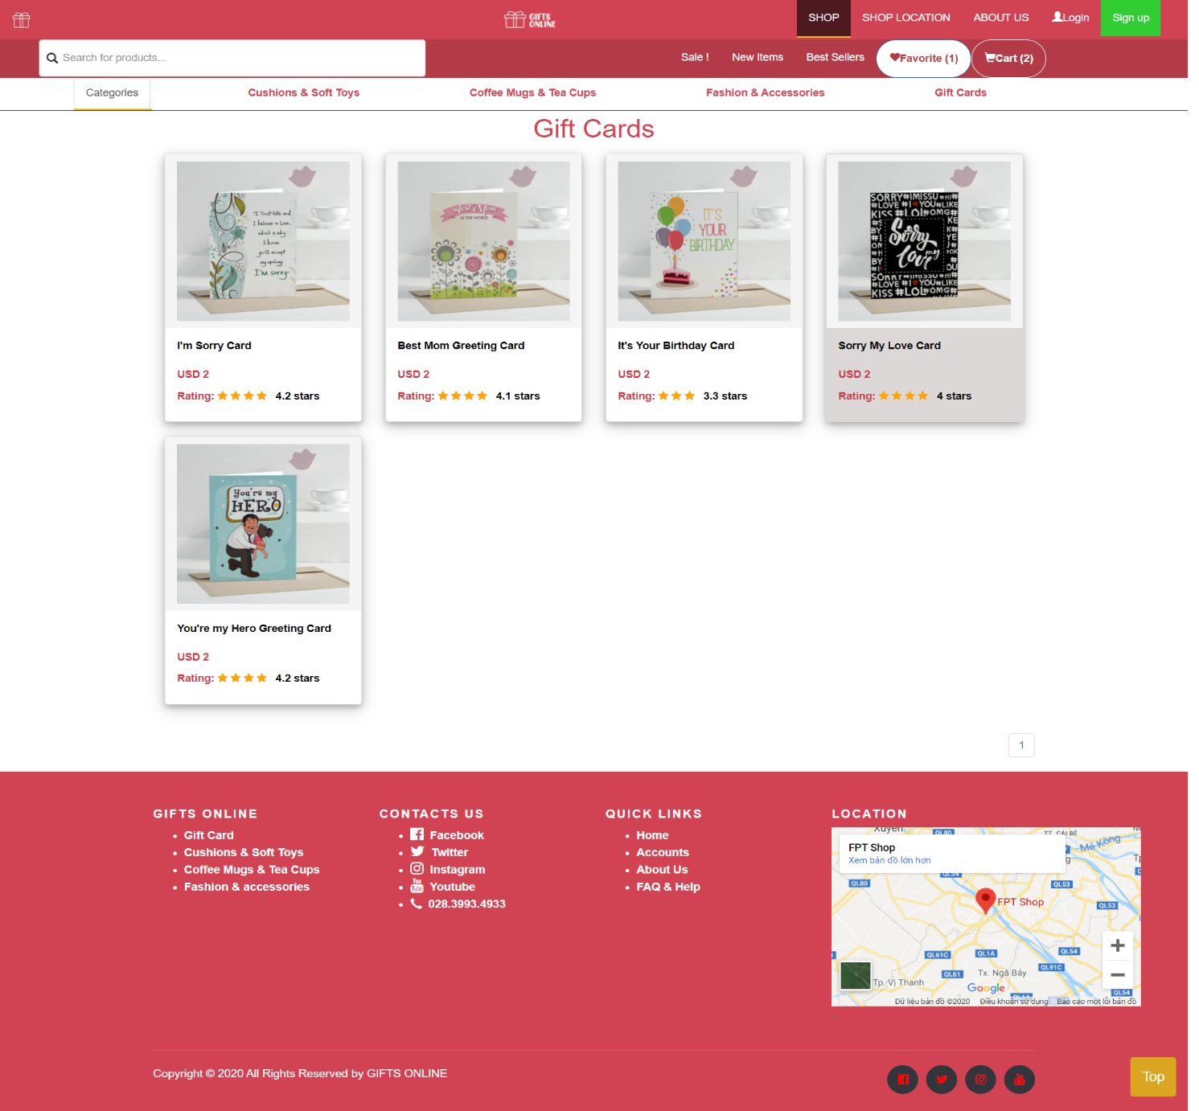

## Item Details Page

Shows all the details about a particular item that a customer wants to know.

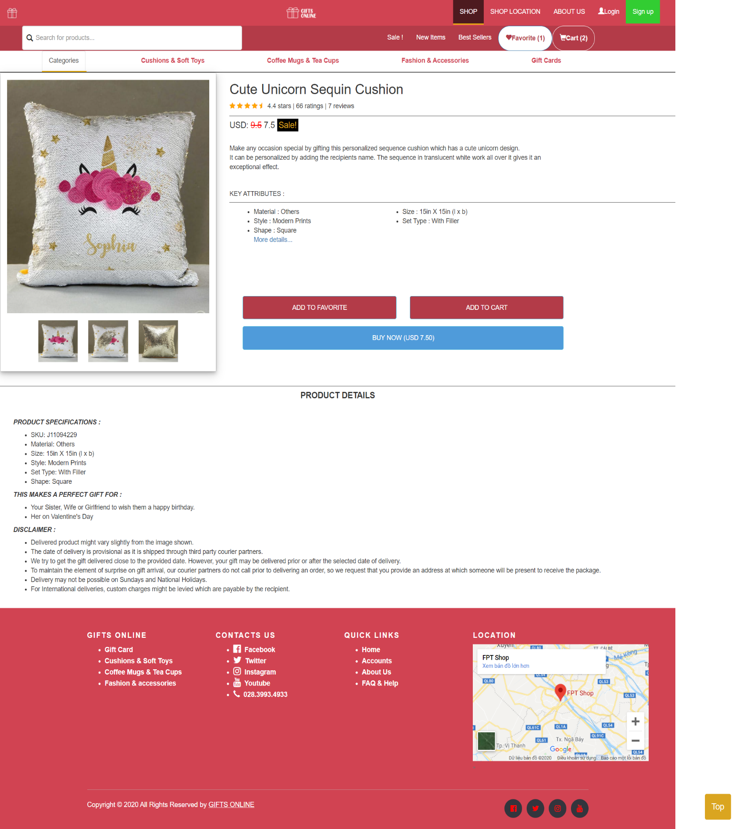

## Footer

Shop’s address with map, main contacts.

Phone number to call us.

Social networks as Twitter, Facebook, Youtube, Instagram to connect with us.



## Payment Page

Pay method:

# TIME MANAGEMENT

STAGE 3 (NOV 8th – NOV 12th)

- Edit and complete website

- Test in different browsers and monitor sizes

- Write Final Project Report

STAGE 2 (OCT 23th – NOV 7th)

- Collect images, details

- Build webpages (HTML, CSS, JS)

- Group to website with links

- Write Project Report

STAGE 1 (OCT 15th – OCT 22th)

- Ideas discussion

- Create layouts for website

- Search for general information for all pages

# TASK SHEET 2

|  |  |  |  |  |  |  |
| --- | --- | --- | --- | --- | --- | --- |
| **Project Ref. No.** | **Project Title** | **Activity Plan Prepared by** | **Date of Preparation of Activity Plan** | | | |
| **Task** | **Actual Start Date** | **Actual Days** | **Teammate Names** | **Status** |
| **Design navigation bar header, Categories (Include coding)** | GIFT ONLINE | Tai | 23/10/2020 | 3 | Tai | Completed |
| **Design Home page and menu Home (include Content and coding)** | GIFT ONLINE | Ngoc | 26/10/2020 | 3 | Ngoc | Completed |
| **Design Feedback, About Us Page, FAQ & Help page and code** | GIFT ONLINE | Thinh | 23/10/2020 | 3 | Thinh | Completed |
| **Design Footer and code (include GeoLocation API)** | GIFT ONLINE | Thinh | 25/10/2020 | 3 | Thinh | Completed |
| **Design Login and Sign up page and code** | GIFT ONLINE | Thinh | 26/10/2020 | 2 | Thinh  Ngoc | Completed |
| **Design Items Page and code(Include content of categories, collecting item’s images, write price, name, rating of items)** | GIFT ONLINE | Tai | 02/11/2020 | 5 | Tai | Completed |
| **Design Item Detail Page and code** | GIFT ONLINE | Ngoc | 29/10/2020 | 5 | Ngoc | Completed |
| **Write content about Item’s detail informations and add to Item Detail Page** | GIFT ONLINE | Ngoc  Tai | 02/11/2020 | 5 | Ngoc  Tai | Completed |
| **Design Payment Page and code** | GIFT ONLINE | Ngoc | 05/11/2020 | 1 | Ngoc | Completed |
| **Group Pages together and update Information** | GIFT ONLINE | Ngoc  Tai | 05/11/2020 | 2 | Ngoc  Tai | Completed |
| **Test Website in different Browsers** | GIFT ONLINE | Ngoc | 05/11/2020 | 2 | Ngoc | Completed |
| **Support to fix and edit code for other members in team** | GIFT ONLINE | Ngoc  Tai | 04/11/2020 | 3 | Ngoc  Tai | Completed |
| **Write project report 2** | GIFT ONLINE | Ngoc | 07/11/2020 | 3 | Ngoc | Completed |

|  |  |
| --- | --- |
| Signature of Faculty | Signature of Leader Team |
|  |  |

# CHECKLIST VALIDATION

|  |  |  |
| --- | --- | --- |
| **Task No.** | **Requirement** | **Validation** |
| 1 | The Home Page should be created making use of Frames with a suitable logo. | Yes |
| 2 | Home Page should contain details of Gift Items with suitable images. | Yes |
| 3 | The site should display a menu which will contain the options for brief introduction about the various gift items available, location of the shop and any other information if required. | Yes |
| 4 | The information about products should be presented in two ways:  + Information should be available category wise, wherein user can click on a particular category and should be able to view all the products related to the category available with complete information. Eg. Category can be “Mugs”, “Cards”, Bracelets” etc. with suitable sub-categories been defined.  + Information should be categorized according to the brand names of the products like if a User wants to see only “Hallmark” products or any other company’s products then he/she can click on a Link/button/menu etc and can see only that Brand products. | Yes |
| 5 | When a user selects any particular brand, a list of products for that brand will be displayed | Yes |
| 6 | A brief summary of features of individual products should be displayed on the Web Page along with the product but detailed Features should be stored in Individual Word documents which can be downloaded or viewed by the User who wishes to see the same. | Yes |
| 7 | The user should also be able to compare the various products of different as well as similar brands. |  |
| 8 | There should be a “Contact Us” page which will have the Address of the Company which is as follows and the mail address which when clicked will invoke the local mail client from where they can send an email. Address of the Company should be displayed using GeoLocation API (eg. GoogleMaps). | Replaced (Mail was placed About Us) |

# REFERRENCE

1. IGP GIFTS Shop

<https://www.igp.com/>

1. Tokyo Otaku Mode Shop

<https://otakumode.com/>